QUIZ
Mathematics Professor: Gohar Marikyan, Ph.D.
Name:_________________________
Date: __________________________

Question 1
Solution .Answer is (D)
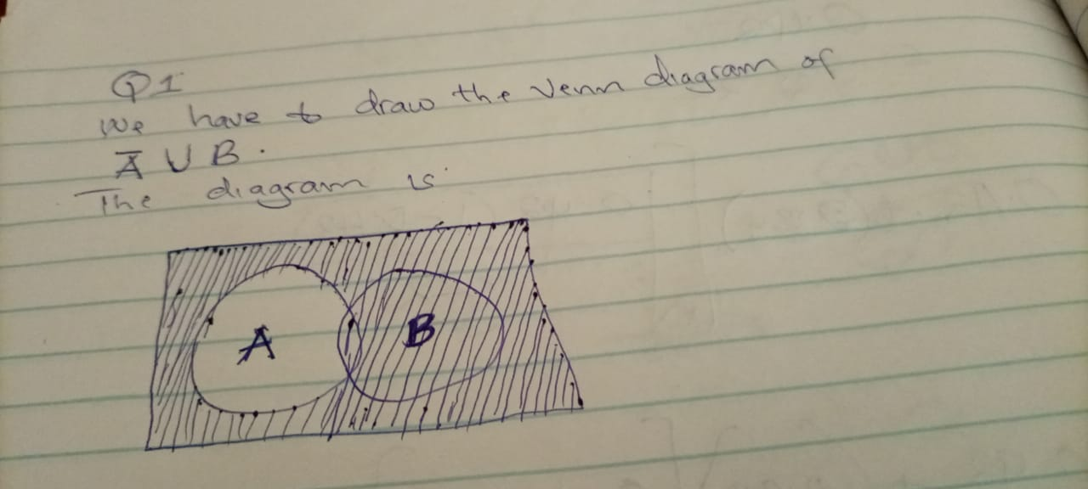

Question 2
Solution Answer is (D)
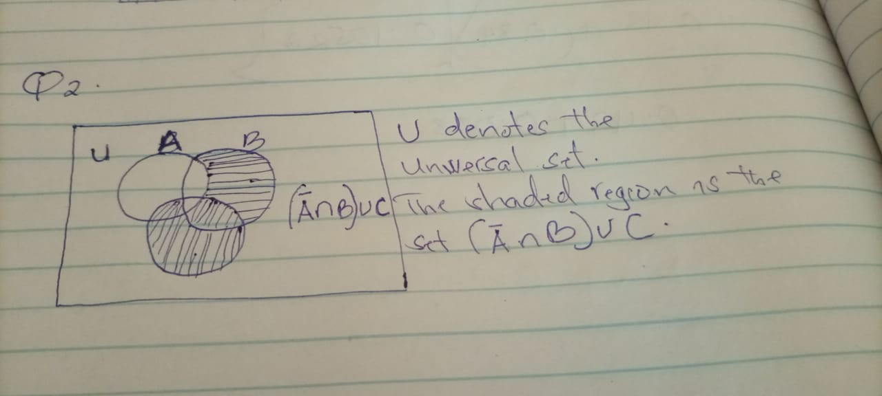
Question 3
Solution. Answer is False.
Let A={m,h,a}
B {a,h,m}
Given {m,h,a} ₵ {a,h,m}
Every element of A is (a) element s of A is (a ) element of B
Therefore, it is False.
Question 4
Solution. Answer (A)
Let A={g,h,d,e,f}, B={j,g,h,i) and C ={m,j,k,l}
( A ∪B)= {g,h,d,e,f} ∪ {j,g,h,i}
A∪B={g,h,d,e,f,j,i} ………………………………….. (i)
Now,
(A∪B)n C ={g,h,d,e,f,j,i} ∩ C ={ g,h,d,e,f,j,i} ∩ { m,j,k,l}
A∪B) ∩C ={ j}
Question 5
Solution.Answer is (A)
Given set is ;
V= {10,22,44,56,66,78,90,100}
A={22,56,78,100}
C={44,66,90}
Now from demorgan theorem ,we know that;
A∪C = A⁻∩ C⁻
= {A-U}∩ {U-C}
={10,44,66,90} ∩{10,22,56,78,100}
A⁻∩ C⁻={10}
Question 6
Solution Answer is (B)
A natural number is a number that occurs commonly and obviously in nature, as such it is a whole, non-negative number. The set of natural numbers, denoted by N can be defined in either of two ways
The set of natural numbers less than 14
Are {1,2,3,4,5,6,7,8,9,10,11,12,13}
Question 7
Answer is FALSE
A natural number is a number that occurs commonly and obviously in nature, as such it is a whole, non-negative number and its denoted by N
Given the numbers as {22,23,24,25}
It’s FALSE to state that such set of natural numbers is greater than 24
Question 8
Solution
Given set is {119,120, 121,122,...}
In set builder notation -
{ x | x ∈ N, x>= 119}
The Answer is ={ x | x ∈ N, x>= 119}
Question 9
If a set has a starting and ending point both then it is finite but if it does not have astarting or end point then it is infinite set.
If a set has a limited number of elements then it is finite but if its number of elements is unlimited then it is infinite
Therefore, { 66,67, 68……} is an Infinite set
Question 10
State whether the statement is true or false.
{2.6} ¢ {2, 3, 4, 5, 6}
Solution
This is False.
Here, {2,6} is contained in {2,3,4,5,6}
Hence, {2,6} is subset of {2,3,4,5,6}
I.e {2,6} C₋ {2,3,4,5,6,}
Question 11
Solution
A = {W,Z,Y,X,a}
B= {b,g,z,a}
C= {e,f,c,d}
(A∩ B) = { A,B,C,W,X,Y,Z}
Now
(A ∩B)∩ C ={ a,b,c,w,x,y,z,} n{ c,d,e,f}
= {C}
Question 12
Solution
A∪C
A ∪C = Take the elements which are present in both A and C
= { 12,24,28,34,40,54,88,}
Total 7 elements
4 from A and 3 elements from “C”
A∪C = U- A∪ C
=Difference of elements in AUC from total elements “U”
= {12,24,28,30,34,40,54,88}
= {30}
Question 13

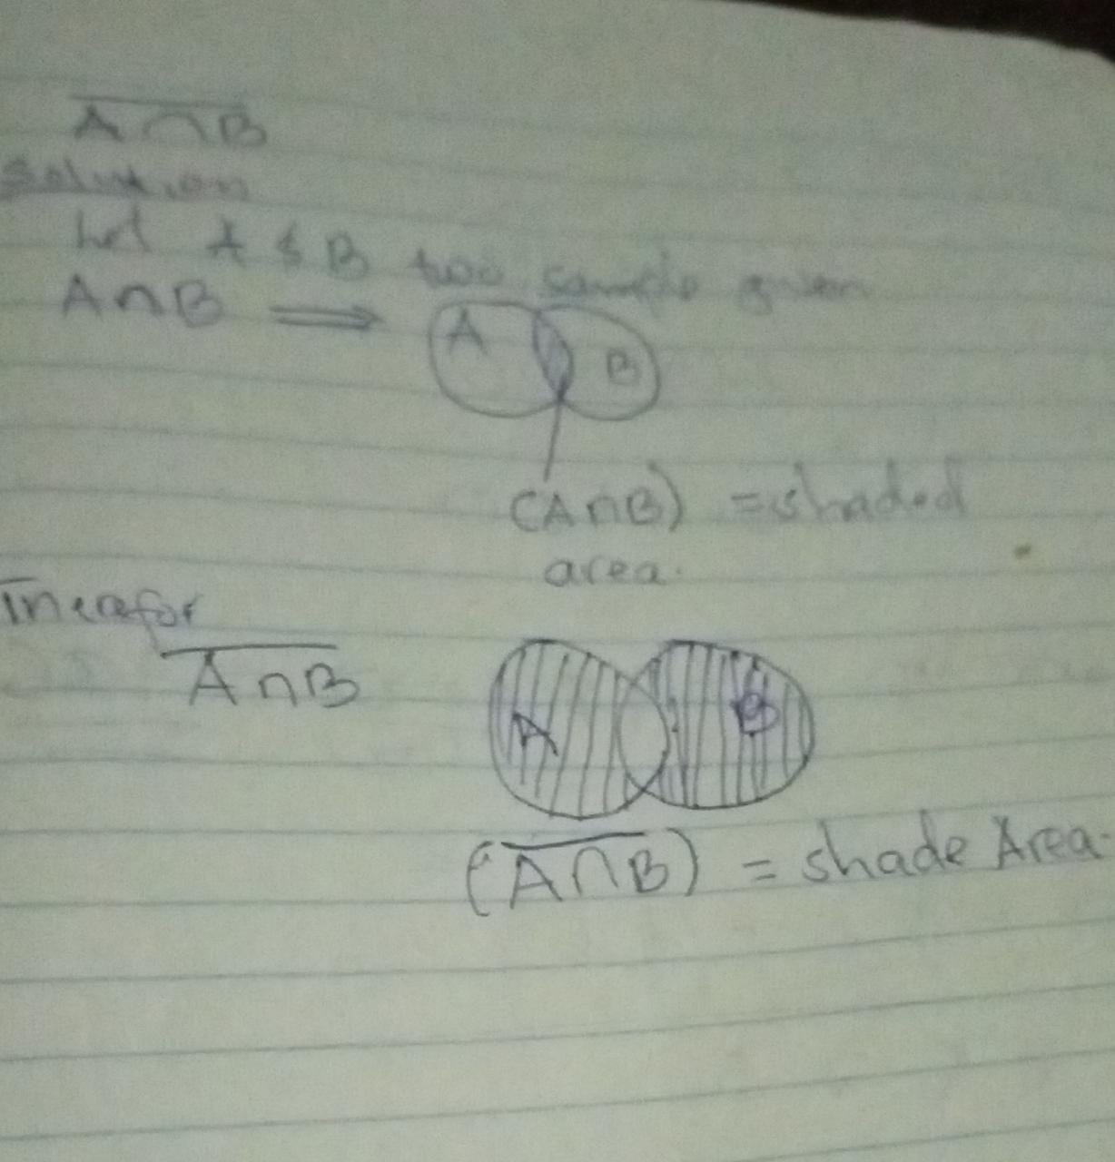
Question 14
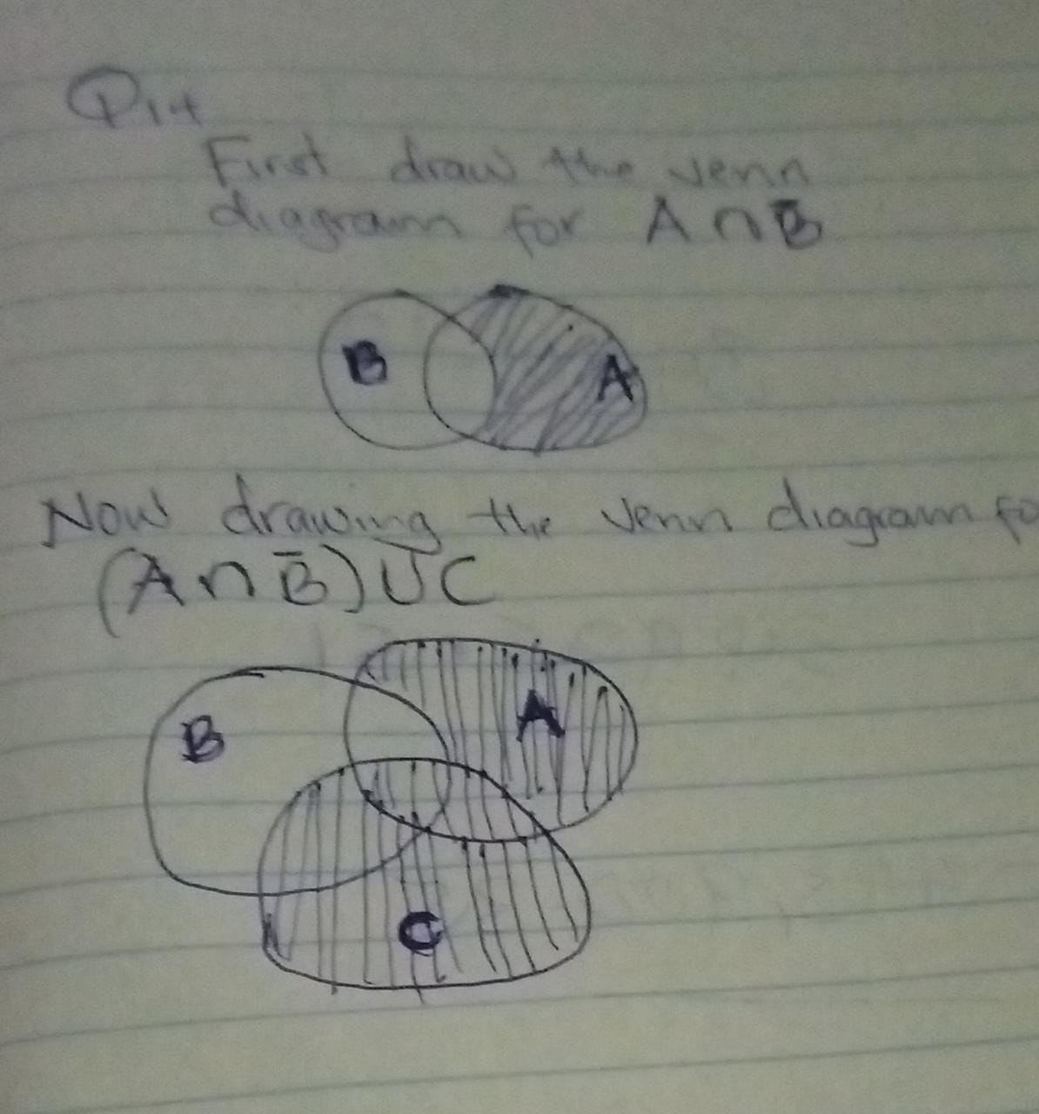
Question 15
Solution

A natural number is a number that occurs commonly and obviously in nature, as such it is a whole, non-negative number. The set of natural numbers, denoted as N ,can be defined in either of two ways
The set of natural numbers less than 16
{1,2,3,4,5,6,7,8,9,10,11,12,13,14,15}
Question 16
A natural number is a number that occurs commonly and obviously in nature, as such it is a whole, non-negative number and its denoted by N
Given the numbers as {18,19,20 21….}
It’s FALSE to state that such set of natural numbers are greater than 19
Answer : FALSE
Question 17
Given set is { 196,197,198,199……} In set builder notation -
{ x | x ∈ N, x>= 196}
The Answer is = { x | x ∈ N, x>= 196}
Question 18
Since x belongs to the natural numbers from 1 to 76.
Therefore given set is finite set
Finite

Question 19
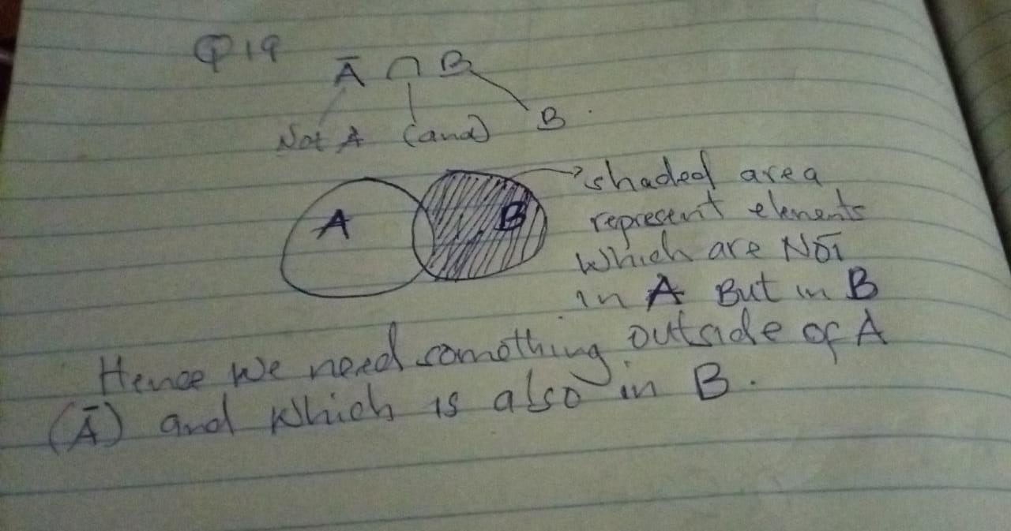
Question 20
Solution
